**Smart tourist guide application**

By

**Md. Asadullah Al Galib**

Roll: 1907035

&

**Md. Atique Faisal**

Roll: 1907038



**Supervisor:**

Abdul Aziz

Assistant Professor

Dept. of Computer Science and Engineering Signature

Khulna University of Engineering & Technology

**Department of Computer Science and Engineering**

**Khulna University of Engineering & Technology**

**Khulna 9203, Bangladesh**

**30 November 2023**

**Acknowledgements**

First and foremost, I must be grateful to and wish to acknowledge my insightful indebtedness to Abdul Aziz, Assistant Professor of the Department of Computer Science and Engineering and the supervisor of the project. His unfathomable knowledge in this field influenced me to carry out this project up to this point. His endless endurance, scholarly guidance, continual encouragement, constant and lively supervision, constructive criticism, and priceless suggestions made it possible to come up to this phase. Without his inspiring, enthusiasm, and encouragement, this work could not have been completed. Last, but by no means least, I thank Allah for the talents and abilities I was given that made it possible to undertake this project.

**Authors**

Md. Asadullah Al Galib

Md. Atique Faisal

**Abstract**

Bangladesh is a land of natural beauty. Bangladesh has had a flourishing tourism sector for the past few years. Many foreign tourists visit here to explore Bangladesh. Along with the rapid development of internet and mobile devices, tour and travel service apps has become very popular. But there is lack of proper information about tourist attractions of Bangladesh in online. Tourists have to face challenges locating nearby attractions, identifying ideal destinations, and accessing relevant information online. This project presents an approachable application created to deal with these problems. This project provides tourists proper information and guideline about all possible tourist spots in Bangladesh along with accommodation, tour plan and other necessary information. To make this project more effective, a chatbot introduced as a virtual tourist guide.

However, the main goal of this project is to bring everything about tour at one place. This project helps both foreigner and Bangladeshi to explore Bangladesh easily.

**Contents**

|  |  |  |
| --- | --- | --- |
|  |  | **Page** |
| Acknowledgement |  | ii |
| Abstract |  | iii |
| Contents |  | iv |
| List of Tables |  | vi |
| List of Figures |  | vii |

|  |  |  |
| --- | --- | --- |
| **1** | **Introduction** | 1 |
|  | 1.1 Background / Problem statement | 1 |
|  | 1.2 Objectives | 3 |
|  | 1.3 Scopes | 3 |
|  | 1.4 *Unfamiliarity of the problem/topic/solution* (Hint: Ensure that the problem idea is not acquired directly from any existing source/course) | 4 |
|  | 1.5 *Project planning* (Hint: Write about the work plan using RACI matrix/Gantt Chart etc.) | 6 |
|  | 1.6 …………………. | 6 |
| **2** | **Related Work** (Optional Section) | 7 |
|  | 2.1 Existing solutions | 7 |
|  | 2.2 Limitation in existing solutions (Hint: Write a summary using table and prove that the problem idea is a new one and not acquired directly from any existing sources) | 8 |
|  | 2.3 ……………………. | 10 |
| **3** | **System Design** | 14 |
|  | 3.1 Analysis of the system (Hint: Include DFD, use case diagram, etc.) | 14 |
|  | 3.2 System architecture (Hint: Include class diagram, detailed architecture of your system, etc.) | 14 |
|  | 3.3 *Tools / Platform used* (Hint: Reason for choosing platform, etc.) | 15 |
|  | 3.3.1 Android Studio | 16 |
|  | 3.3.2 Kotlin | 17 |
|  | 3.4 …………………… | 19 |
| **4** | **Project Implementation** | 22 |
|  | 4.1 System implementation (Also include User Manual considering Front End) | 22 |
|  | 4.2 *Morality or Ethical issues* (Hint: Proper citations or acknowledgement and plagiarism) | 24 |
|  | 4.3 *Socio-economic impact and sustainability* (Hint: Write down the impact of the project on societal, health, safety, legal, and cultural issues also the impact of project on the environment and sustainability) | 25 |
|  | 4.4 *Financial analyses and budget* (Overall budget planning or Component / Software Budget planning. It can be written in Appendices also.) | 26 |
|  | 4.5 ………. | 27 |
| **5** | **Conclusions** | 28 |
|  | 5.1 Conclusion and challenges faced | 28 |
|  | 5.2 Future work | 29 |
|  | 5.3 …………. | 30 |
|  |  |  |
|  | **References** | 31 |
|  | Appendices (If any) |  |

**List of Tables**

|  |  |  |
| --- | --- | --- |
| **Table No.** | **Description** | **Page** |
| 2.1 | Network construction using Physarum. | 6 |
| 3.1 | Time comparison in car, bus and bicycle. | 23 |

**List of Figures**

|  |  |  |
| --- | --- | --- |
| **Figure No.** | **Description** | **Page** |
| 3.1 | Real traffic network. | 16 |
| 4.1 | Selected Dhaka city Map. | 18 |

1. Introduction

Bangladesh offers many tourist attractions, including archaeological sites, historical mosques and monuments, longest natural beach in the world, picturesque landscape, hill forests and wildlife, rolling tea gardens and tribes. Tourists find the rich flora and fauna and colorful tribal life very enchanting. Tourist industry becomes a vital contributor to the national economy and a significant source of employment. Modern technology brings the world in our hand. So, it is a demand of this age to make tourism in Bangladesh explorable easily to the modern world.

* 1. Background

Bangladesh has emerged as a destination of natural beauty, attracting a growing number of foreign tourists eager to explore its diverse landscapes and cultural heritage. There are some tourist sites and mobile apps in online. But there is not proper information about tourism in Bangladesh. Again, all necessary information can’t be found at one place. Tourists need to give more time in browsing for getting necessary information. Again, tourism in Bangladesh is growing rapidly and contributing to economy. A research on tourism and economics growth of Bangladesh [7] shows how tourism is growing in Bangladesh. That research shows a graph how tourism contributes on GDP of Bangladesh (1996-2020) which is given below-

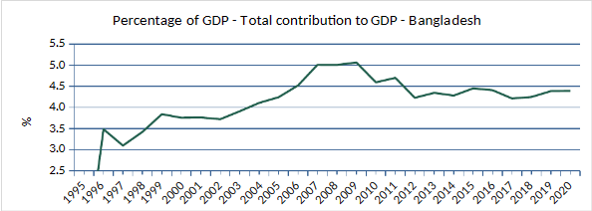

**Figure 1.1:** Contribution of tourism in economic growth in Bangladesh

To solve existing gap in online information and make tourism more attractive we introduce a smart tourist guide android app named “Ghuraghuri”.

* 1. Objectives

1. To create a comprehensive tourism information platform.
2. To implement tour booking functionality.
3. To provide tourists necessary tools.
4. To implement virtual tourist guide chatbot.
5. To centralize everything about tour at one place.
6. To explore and introduce the beauty of Bangladesh world-wide.
   1. Motivation:

Our idea is to develop an android application which contribute in tourism sector in Bangladesh. In Bangladesh there many tourist spot which is not properly explorable in online. So, these attractions remain undiscoverable from people. Again, we need to give a certain amount of time in browsing to collect different information. There is a website named “Tripadvisor”[2] which provide many tour guidance. But it also have lack of information about Bangladesh tourism and there are many local tourist spots which are not included threre. So, those things inspired us to develop something unique and give centralized tour facilities for tourism in Bangladesh.

* 1. Unfamiliarity of the problem

There are some websites and mobile application which provide tour and travel support. There are also many facebook pages and other tourist organization which arrange tour for tourists. But different websites have different purposes. Again, it is difficult for getting proper data about Bangladesh from those websites. But as we said before, our main goal is “To Bring Everything about Tour at One place.” The uniqueness of our project are-

* It will provide all necessary information about tour at a single platform.
* As various agencies can offer their tour, this app provide a common platform for tour agencies.
* It will also provide facilities to buy necessary tools for tour. So, tourists don’t need to go other platform.
* It also provides facilities to write blog and share vlog at the same platform.
* The most interactive unique feature is virtual tourist guide chatbot.
  1. Project planning

Project planning in shown in the gantt chart below-



**Figure 1.2:** Gantt chart of project planning

1. Related Works

There are some related research papers which work on tour guide application.

* 1. Related works

1. There is a flutter based application [1] which give related facilities as our project. That focuses on web scrapping, image recognition and finding tour guide online. That is very good idea. But web scrapping is not efficient for our project as there is not proper data about tourism in Bangladesh in online.
2. Another related work found which works on Portugal tourism [3]. That works on only tour recommendation system based on user interest.
3. Based on the technology acceptance model (TAM) a mobile guide app is developed to provide managerial functionalities for travel agencies. [4]
4. Local tourism organizations use online and offline advertising to attract tourists. They provide real-time information through social media platforms like Twitter and Facebook. That study aims to develop a user-participating app to sustain user interest in tourism resources and attract more tourists to regional destinations. [5]
5. University campuses are large, dispersed buildings, causing inconvenience for unfamiliar students, teachers, and foreign office personnel. [6] That study focuses on only university guidance.
6. System Design

We designed our app for 3 types of user – tourist, agency and admin. We design a beautiful UI. This app is user friendly. The deep analysis of the system is discussed here.

* 1. Analysis of the system

For tourist:

* Tourists can discover attractive tourist spots in Bangladesh.
* They can get necessary information including near-by hotel, restaurant, bank/atm, hospital, police station, main attractions, speciality of tourist spot.
* They can observe weather condition of tourist spot for arranging tour.
* Attractive image gallery of tourist spots.
* They can make custom tour plan.
* They can share their experience by writing blog and adding youtube video.
* They can book tour offered by various agency.
* They can buy necessary tools for a tour.
* Virtual tourist guide chatbot helps them to quickly and conveniently get important information.
* They can give rating and review of any tourist spot.

For agency:

* Various tourist agencies can offer their tour.
* Simple dashboard tour management.

For admin:

* Only authorized person can access admin panel.
* Add tour and add product.
* Simple dashboard for managing order of tourist.

Optimized searching:

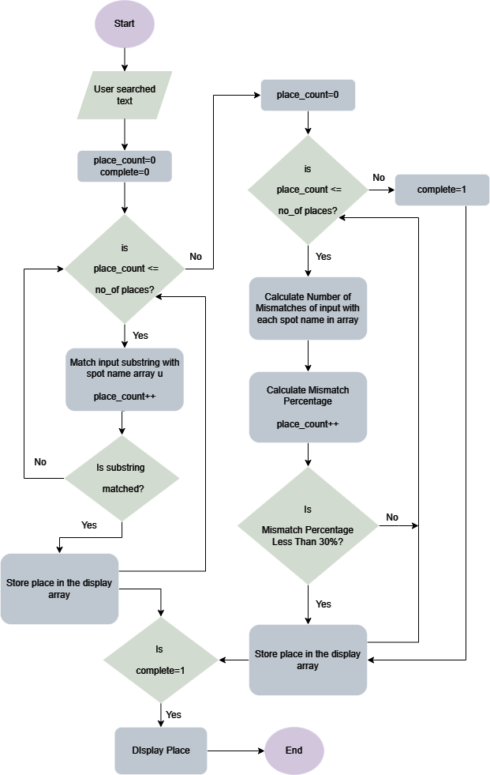

**Figure 3.1:** Flow chart for optimized searching

Map activity:

Map activity is used for displaying attractions, hotel, restaurant, hospital and police station in map view. Here google map API is used. The name of places are retrieved from database and search in the geocoder class. If the place is found, marker is put on the location at map view. Pseudocode is given below-

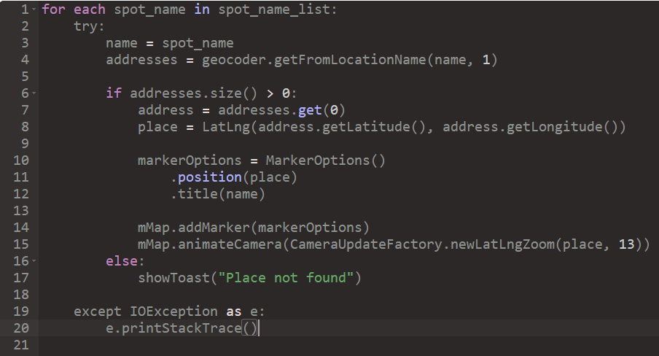

**Figure 3.2:** Pseudocode for map_activity

Embedding youtube video:

To embed youtube video in android we this [android-youtube-player](https://github.com/PierfrancescoSoffritti/android-youtube-player) library. To Implement this video id is required. Videos are showed in recyclerview. Full screen facility is also included.

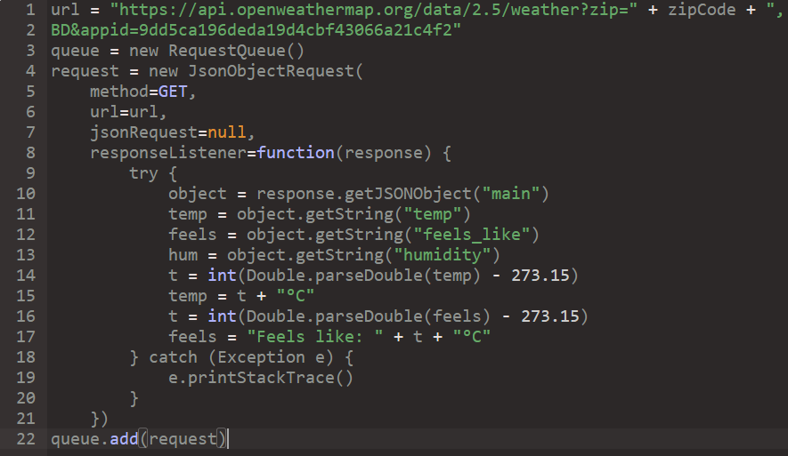Weather information:

We use OpenWeather API to get real-time weather information. Here json parsing is required. So, we use [volley](https://github.com/google/volley) library. Pseudo code is shown here.



Use case diagrams:

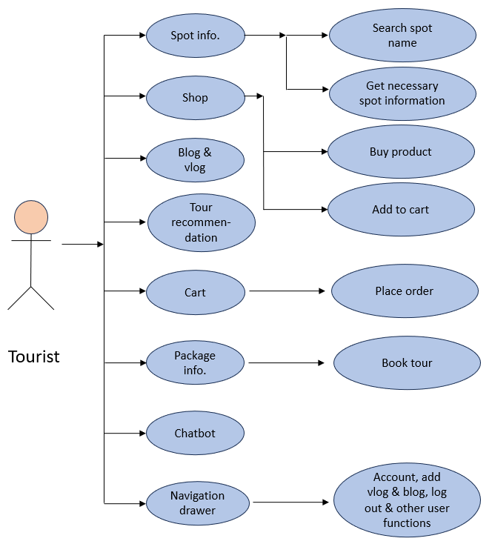

**Figure 3.4:** Use case diagram for tourist

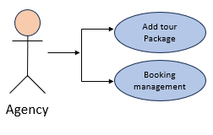 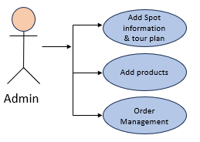

**Figure 3.5:** Use case diagram for admin

* 1. System architecture

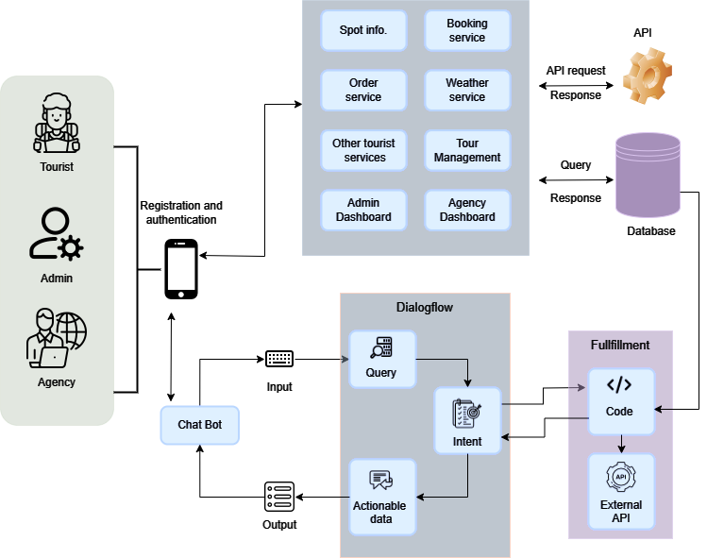

* 1. Tools used

This an android application. The tools used for it are described below-

* + 1. Android Studio

Android Studio is the official integrated development environment (IDE) for Android app development. Based on the powerful code editor and developer tools from [IntelliJ IDEA](https://www.jetbrains.com/idea/). it has fast and feature-rich emulator. It gives powerful suggestion. It has extensive testing tools and frameworks.

* + 1. Java

This project is fully built using java programming language.

* + 1. Firebase

Firebase is used for online database. The services used from firebase are-

1. Authentication -> It is used for sign up and sign in.
2. Realtime database -> To store all necessary information in database.
3. Storage -> To store images.
   * 1. API

The API used for this project-

1. Google map API -> To access google map service.
2. Open weather API -> To implement weather forecast.
   * 1. Libraries

Other libraries used for this project is –

1. [Glide](https://github.com/bumptech/glide) -> It is used for image management.
2. [Android-Image-Slider](https://github.com/smarteist/Android-Image-Slider) -> It is used for image slider.
3. [volley](https://github.com/google/volley) -> It is an HTTP library that makes networking for Android apps easier and, most importantly, faster.
4. [android-youtube-player](https://github.com/PierfrancescoSoffritti/android-youtube-player) -> It is used for embedding youtube video in android app.
   * 1. Dialogflow

Dialogflow is a comprehensive platform for developing chatbots, voice bots, and virtual agents using natural language understanding and Google AI. It is used in this project to implement chatbot.

1. Project Implementation

The step by step project implementation will be shown here

* 1. System implementation

User manual is shown below-

For tourist:

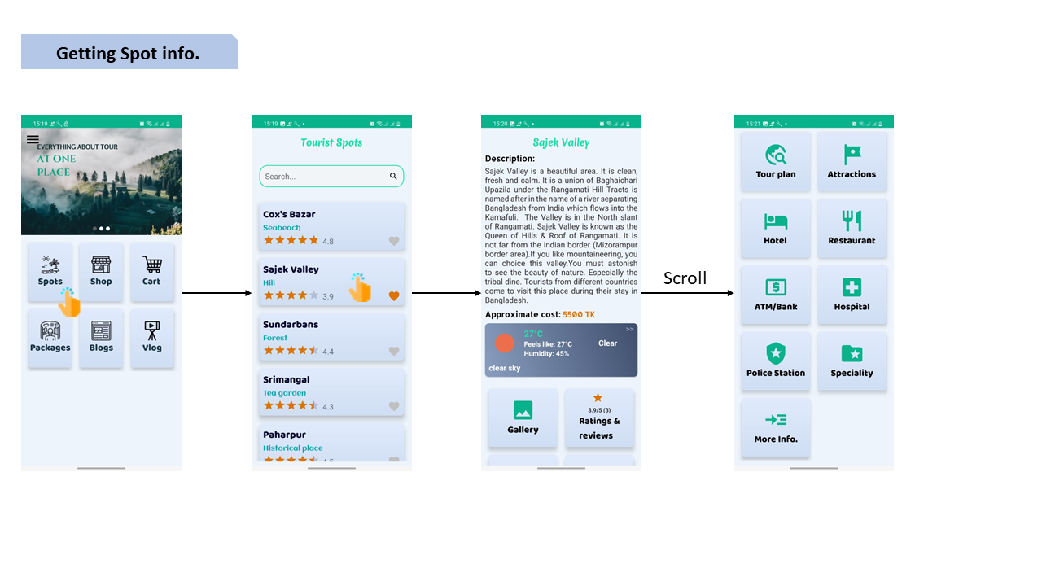

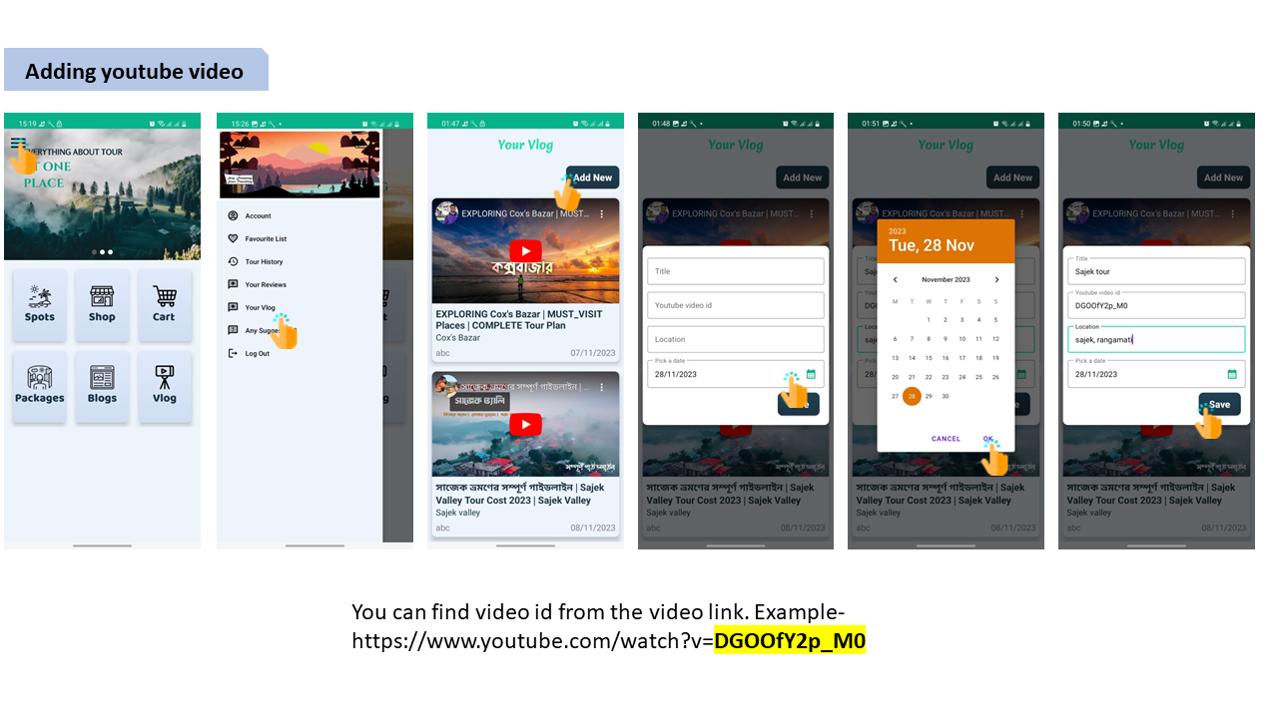

* 1. Socio-economic impact and sustainability

* **Boost economies:** This project gives facilities tourist to discover and explore new destination. It increases tourism which leads to greater revenue for local business as well as national economy.
* **Community engagement:** It provides facilities to share user-generated content such as, blogs and videos which attracts more tourist. This creates sense of community among tourists as well as encourages individuals to share their experiences and insights.
* **Engage tourist agencies:** This project creates a market place for various tourist agencies to offer their tours. It creates a healthy competition among agencies to support tourists for making tour more enjoyable.
* **Safety and security:** This platform provides information about location of hospitals, police station and other essential services that enhance the safety and security of tourists.
* **Modern technology adoption:** The inclusion of virtual tourist guide chatbot encourages tourist to adopt modern technology and increases efficiency of work.
* **Job facilities:** As this project contributes in growth of tourism, it creates job facilities in various sectors. Again, this project needs man power to gather actual data and management. So, it may create job opportunities for tourist guides.
  1. Financial analyses and budget

We use free API and libraries for this project. That’s why can’t be able to implement some attractive and more dynamic features. For cost estimation only elapsed time can be come into consideration. It Takes around 3 months to complete this project.

1. Conclusion

This project helps tourists to explore Bangladesh easily. It also helps people who want to know some information about any tourist spot Bangladesh. It centralizes diverse needs of tourist at one place. Proper marketing policy and investment can make this project more efficient, attractive and introduce Bangladesh all over the world. However, it takes a lot of hard work and we faced some challenges to execute this project and this is not the final version. We have some plan to do some update in future.

* 1. Conclusion and challenges faced

As we don’t use any third-party API to gather tourist spot information, we need to gather information manually. This is very difficult to gather huge information. So, we gather some spot information for project showcase. To implement chatbot we need to face some difficulties. We can’t find any proper dataset to train chatbot. To integrate it with android project we need to face some errors.

* 1. Future work

# Now our database is limited. We need to gather more information to represent proper information. We will work on it in future.

* Our chatbot is now in basic level. It can be updated further.
* A virtual assistant can be implemented which can communicate with tourists to support real-time guide facilities.
* Real time transportation information can be implemented from which tourist can know how to go desired destination from any location.
* As we use free google map API, the paid map services can’t be accessed such as nearby location.

# 

# References

[1] B. Maulik, A. P. Nayak, S. U, S. Alok and D. K. N, "Design and Implementation of Virtual Tour Guide App," 2022 International Conference on Advanced Computing Technologies and Applications (ICACTA), Coimbatore, India, 2022, pp. 1-6, doi: 10.1109/ICACTA54488.2022.9752804..

[2] Stephen Kaufer, Langley Steinert, Tom Palka, Nick Shanny. [Online] . Available: https://www.tripadvisor.com/

[3] Larga, F. E. da S. V. (2020). A mobile tour guide app for sustainable tourism [Dissertação de mestrado, Iscte - Instituto Universitário de Lisboa]. Repositório Iscte. http://hdl.handle.net/10071/22033

[4] Chung-Ming Chuang (2020) A current travel model: smart tour on mobile guide application services, Current Issues in Tourism, 23:18, 2333-2352, DOI: 10.1080/13683500.2019.1631266

[5] W. Seok, "A Study of User Participatory Mobile App," 2018 7th International Congress on Advanced Applied Informatics (IIAI-AAI), Yonago, Japan, 2018, pp. 984-985, doi: 10.1109/IIAI-AAI.2018.00212.

[6] Y. Liu, Y. Wang, K. Lei and J. Zhang, "Design and Implementation of Intelligent Tour Guide Application System," 2022 IEEE 10th Joint International Information Technology and Artificial Intelligence Conference (ITAIC), Chongqing, China,

[7] !&B?&0!+. 5 /+01--9#+

KYAU Journal+6./6'*

!&B?&0!+. 5 /+01--9#+

KYAU Journal+6./6'*

[7] Aktar MS, Huq SM, and Talukder MA. (2021). Tourism and Economic Growth of Bangladesh. KYAU Journal. 4(1),41-51

**N.B.** This is the preferable format for Report writing. The subsections written in italic forms (i.e., 1.4, 1.5, 4.2, 4.3, 4.4) are fixed. However, the Supervisor can extend the sections/points of the report (if necessary).